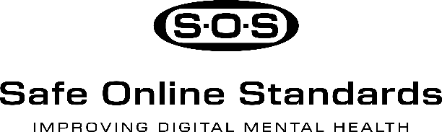

Sample Social Media Posts

Twitter (X)
Post 1 – Awareness

Big news!
Safe Online Standards (S.O.S.) Rating System officially launched, a first-of-its-kind resource to help families understand how well online platforms protect youth mental health and digital well-being.

Expert-led. Youth-informed. Designed for transparency, accountability, and safer digital spaces.

It’s time to expect more from the platforms young people use every day.

#S.O.S. #OnlineTrust #DigitalWellness #MentalHealthMatters #YouthSafety

Post 2 – Quick Tips
Want a healthier digital experience? Start here:
1️⃣ Check privacy settings
2️⃣ Turn off location tracking
3️⃣ Mute or block harmful accounts
4️⃣ Set screen time limits
5️⃣ Choose S.O.S.-rated platforms you can trust
#SOS #DigitalAccountability #OnlineWellness

Post 3 – Myth-Busting
Myth: All tech platforms treat users the same.
Truth: They don’t.
That’s why S.O.S. exists, the first-ever rating system for technology platforms.
#SOS #DigitalTrust #KnowBeforeYouPost #OnlineWellness
Instagram
Carousel: Making Informed Online Choices
Slide 1:
“Which platforms put users first?”
The S.O.S. Rating System shows you.
Slide 2:
Does your feed feel overwhelming?
“Not all platforms are built the same, some support mindful use, others push endless scrolling.”
Slide 3:
Are you safe online?
S.O.S. checks how platforms handle your information
Slide 4:
Transparency is everything
What really happens when you report harmful content?
Slide 5:
Your mental health and well-being matter
S.O.S. helps you choose platforms that respect your time and your trust
Caption:
What makes you trust a platform ?
Tell us in the comments and save this post for later
#S.O.S. #DigitalWellness #ScrollSmarter #OnlineAccountability
Facebook
Post 1 – Digital Habits That Protect You
Big news from MHC: The Safe Online Standards (S.O.S.) are here.
Why it matters:
✅ They help you make informed choices online
✅ Backed by experts, shaped by real users
✅ They rate platforms on trust, privacy, and accountability
Let’s change the digital world together.
#OnlineAccountability #S.O.S. #DigitalTrust

Post 2 – Why We Need S.O.S.?
Did you know 4 in 10 users report experiencing online harassment?
SOS is here to change that with the first-ever rating system for technology platforms.
It asks the tough questions:
- Are abuse reports taken seriously?
- Is mental health supported?
- Are your rights respected?
With S.O.S., you’ll know which platforms deserve your trust.
Let’s build a healthier digital world together.
#TransparencyMatters #S.O.S. #DigitalWellness

LinkedIn
The Need for Stronger Online Standards for Youth
It’s time to rethink how we approach social media accountability.
It’s the first of its kind to rate platforms based on transparency, governance, and user protection.
Why it matters:
• Young people deserve digital spaces that respect and protect their well-being.
• Families and educators need clear, trusted guidance
• Tech companies must be held accountable
S.O.S. is expert-driven, youth-informed, and built to empower choice. Let’s work toward a safer digital future together
What changes would you like to see in how platforms respect and protect users?
#DigitalWellness #TransparencyMatters #OnlineTrust #YouthEmpowerment #S.O.S.
TikTok (Storyboard)
Scene 1 – “What We Want You to Know”
Visual: Student scrolling, stressed on one side (dark), calm and confident on the other (bright).
VO/Text: “Not all online spaces respect your well-being. SOS helps you choose better ones.”
Scene 2 – “The First-Ever Ratings”
Visual: Look for platforms scored with S.O.S. a shield, caution or warning sign.
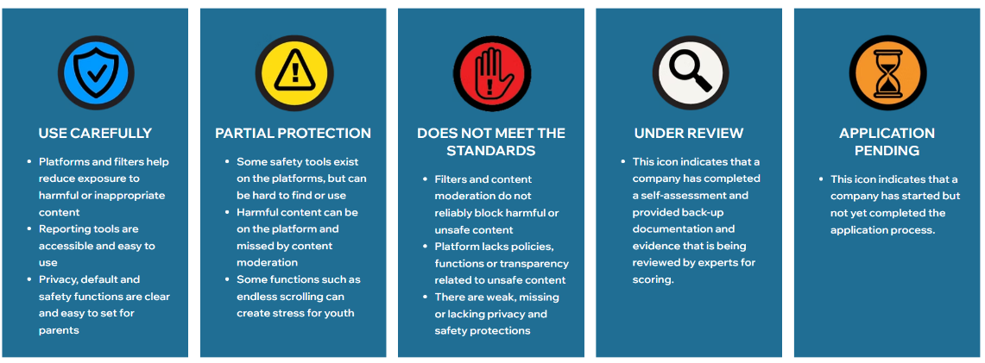
VO/Text: “For the first time, platforms are being rated for how accountable and transparent they are.”
Scene 3 – “How YOU Can Make a Difference”
Visual: Student reporting content, turning on privacy, setting limits.
VO/Text: “Be informed. Be empowered. Choose platforms that put your well-being first.”
Scene 4 – Final Call to Action
Text on screen: “Tag a friend who needs to know about Safe Online Standards!”
Hashtags: #S.O.S. #OnlineTrust #ThinkBeforeYouClick #DigitalWellness #ScrollSmarter

