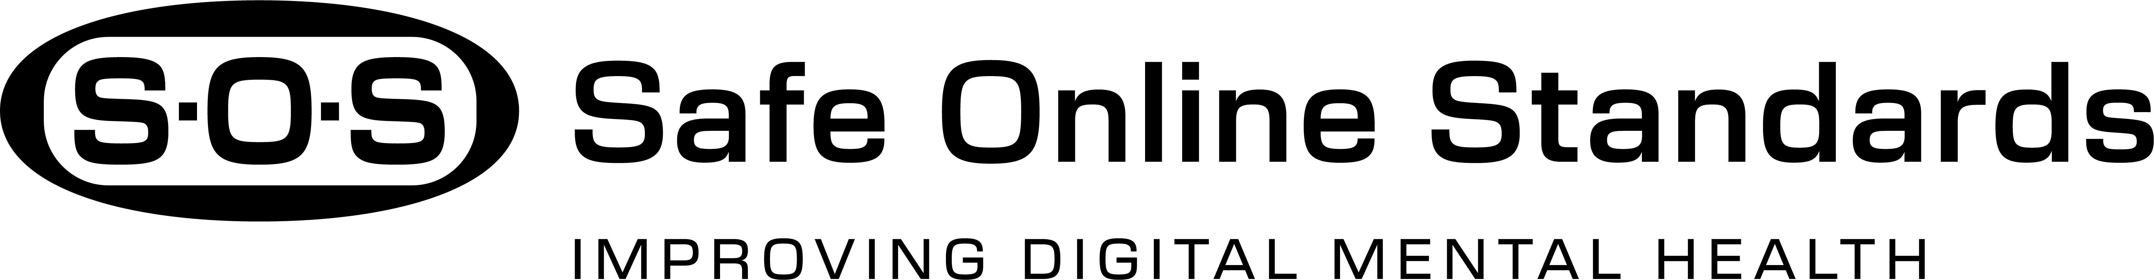
The S.O.S. Story: Advancing Safe Online Standards
The World Has Changed
From the way we get news to how we connect with friends; the digital world now shapes nearly every part of daily life. Smartphones give us instant access to information, entertainment, and connections that once required libraries, landlines, or calculators. But while digital convenience is at our fingertips, it also brings real risks. Families are left to wonder whether the platforms they use are truly safe and if they support or undermine the well-being of young people.
While digital convenience is at our fingertips, it brings risks. Many are left to question whether the platforms they use truly protect them and whether those spaces support or undermine their mental health & well-being.
Online Safety Matters
The Problem
Digital technology now plays a central role in daily life, especially among youth. As of January 2025, over 7 billion smartphones are in use worldwide, and 75% of people over 13 use social media. Teens spend an average of 7–8 hours a day on screens, and every day, 1 billion health-related questions are asked on Google.
While these platforms offer entertainment and connection, their excessive and unregulated use can worsen mental health challenges. Right now, there are no universal standards, consistent guidance for families, or trusted systems to show which platforms truly protect young people.
The S.O.S. Answer
This is the world’s first rating system designed to show how well social media and technology companies protect mental health, support well-being, and handle suicide-related content.
S.O.S. works much like safety ratings for cars or nutrition labels on food, giving families a clear and trusted way to understand risks. Developed with experts, research, and feedback from youth, parents, and educators, the S.O.S. standards evaluate companies across five key areas: Policies, Governance and Transparency, Functionality, Content, and Digital Literacy and Well-Being.

Global Endorsements
The S.O..S initiative has received support from more than a dozen leading experts in youth mental health, suicide prevention, and online safety. Endorsing organizations include Active Minds, Child Mind Institute, Didi Hirsch, Safe in Our World,
Teen Line – A Program of Didi Hirsch, and the International OCD Foundation. These organizations represent countries such as the United States, the United Kingdom, Austria, and Australia.
How You Can Help
While S.O.S. is established, its success depends on reaching families, youth, and professionals. With broader support, S.O.S. can:
• Reach educators and students in schools, youth groups, and community programs
• Equip parents with tools to talk about digital safety and platform ratings
• Help healthcare providers guide families on the mental health impact of technology
The Road Ahead
This is only the beginning. With continued partnership and engagement, S.O.S. can become a standard part of everyday digital life. The vision is clear: a future where online safety is visible, reliable, and actionable for everyone.
Together, we can reduce digital harm and build a healthier, safer future for all. Join S.O.S. and take the next step toward lasting change.
IMPORTANT NOTE: Every online platform carries risks. The S.O.S ratings are intended to guide families toward safer choices, initiate important conversations, and support youth mental health and suicide prevention. While these ratings highlight how well platforms perform and meet safety and well-being standards, they do not address every possible issue young people might face. Parental involvement, open communication, and ongoing awareness remain essential, even for platforms with the highest safety ratings. This is version 1.0 of the S.O.S. Ratings and will evolve with new insights and user feedback.

