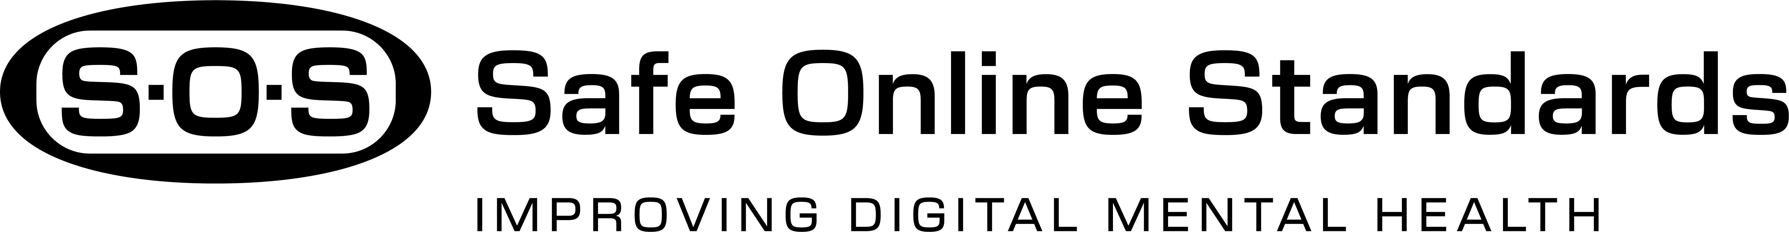

Sample Social Media Posts

Twitter (X)
Post 1 – Awareness
Big news: The MHC just launched the Safe Online Standards (SOS) rating system.
Expert-led. User-informed. Built to support youth’s mental health and well-being.
Let’s demand transparency and accountability on every platform.
#SOS #OnlineTrust #DigitalWellness

Post 2 – Quick Tips
Want a healthier digital experience? Start here:
1️⃣ Check privacy settings
2️⃣ Turn off location tracking
3️⃣ Mute or block harmful accounts
4️⃣ Set screen time limits
5️⃣ Choose SOS-rated platforms you can trust
#SOS #DigitalAccountability #OnlineWellness

Post 3 – Myth-Busting
Myth: All platforms treat users the same.
Truth: They don’t.
That’s why S.O.S. exists, the first-ever rating system for digital platforms.
Now you’ll know who’s looking out for you.
#SOS #DigitalTrust #KnowBeforeYouPost #OnlineWellness

Instagram
Carousel: Making Informed Online Choices
Slide 1:
“Which platforms put users first?”
The SOS Rating System shows you.
Slide 2:
Does your feed feel overwhelming?
“Not all platforms are built the same, some support mindful use, others push endless scrolling.”

Slide 3:
Are you safe online?
SOS checks how platforms handle your information
Slide 4:
Transparency is everything
What really happens when you report harmful content?
Slide 5:
Your mental health and well-being matter
SOS helps you choose platforms that respect your time and your trust
Caption:
What do you look for in a trustworthy platform?
Tell us in the comments and save this post for later
#SOS #DigitalWellness #ScrollSmarter #OnlineAccountability

Facebook
Post 1 – Digital Habits That Protect You
BIG NEWS: The Safe Online Standards (S.O.S.) are here!
Why it matters:
✅ They help you make informed choices online
✅ Backed by experts, shaped by real users
✅ They rate platforms on trust, privacy, and accountability
Let’s change the digital world together.
#OnlineAccountability #S.O.S. #DigitalTrust

Post 2 – Why We Need SOS?
Did you know 4 in 10 users report experiencing online harassment?
SOS is here to change that with the first-ever rating system for digital platforms.
It asks the tough questions:
- Are abuse reports taken seriously?
- Is mental health supported?
- Are your rights respected?
With S.O.S., you’ll know which platforms deserve your trust.
Let’s build a healthier digital world together.
#TransparencyMatters #S.O.S. #DigitalWellness

LinkedIn

The Need for Stronger Online Standards for Youth
It’s time to rethink how we approach social media accountability.
It’s the first of its kind to rate platforms based on transparency, governance, and user protection.
Why it matters:
• Young people deserve digital spaces that respect and protect their well-being.
• Families and educators need clear, trusted guidance
• Tech companies must be held accountable
S.O.S. is expert-driven, youth-informed, and built to empower choice. Let’s work toward a safer digital future together
👉 What changes would you like to see in how platforms respect and protect users?
#DigitalWellness #TransparencyMatters #OnlineTrust #YouthEmpowerment #S.O.S.

TikTok (Storyboard)

Scene 1 – “What We Want You to Know”
Visual: Student scrolling, stressed on one side (dark), calm and confident on the other (bright).
VO/Text: “Not all online spaces respect your well-being. S.O.S. helps you choose better ones.”
Scene 2 – “The First-Ever Ratings”
Visual: Platforms scored with SOS shield, 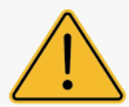 Caution, and X Warning
VO/Text: “For the first time, platforms are being rated for how accountable and transparent they are.”
Scene 3 – “How YOU Can Make a Difference”
Visual: Student reporting content, turning on privacy, setting limits.
VO/Text: “Be informed. Be empowered. Choose platforms that put your well-being first.”
Scene 4 – Final Call to Action
Text on screen: “Tag a friend who needs to know about Safe Online Standards!”
Hashtags: #S.O.S. #OnlineTrust #ThinkBeforeYouClick #DigitalWellness #ScrollSmarter

